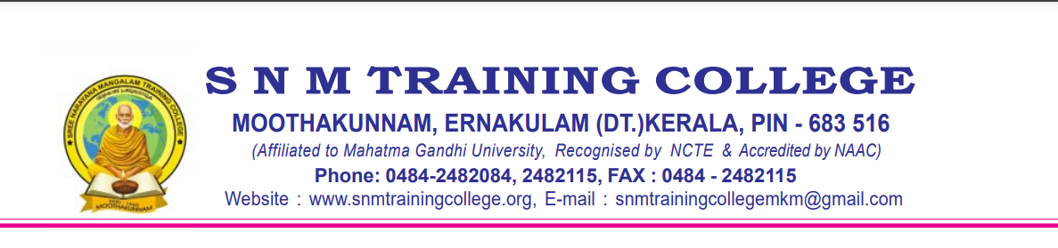

**STUDENT SATISFACTION SURVEY 2023-2024 Academic Year**

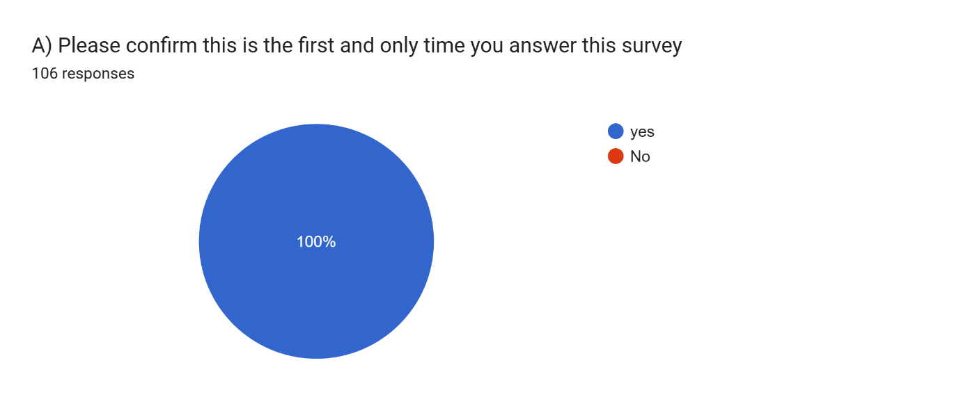

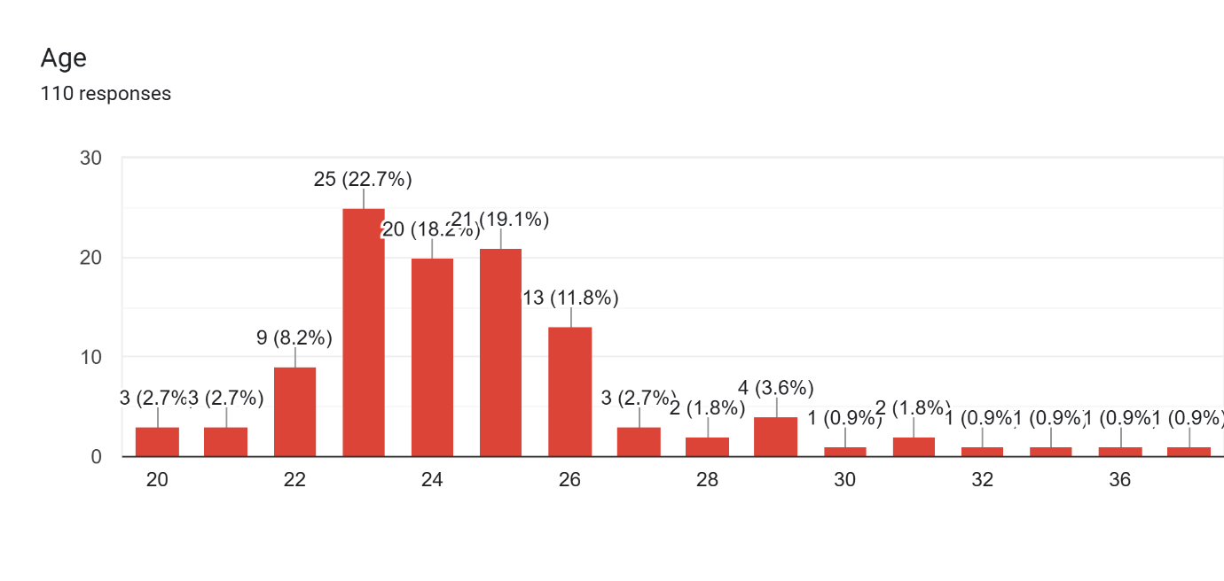

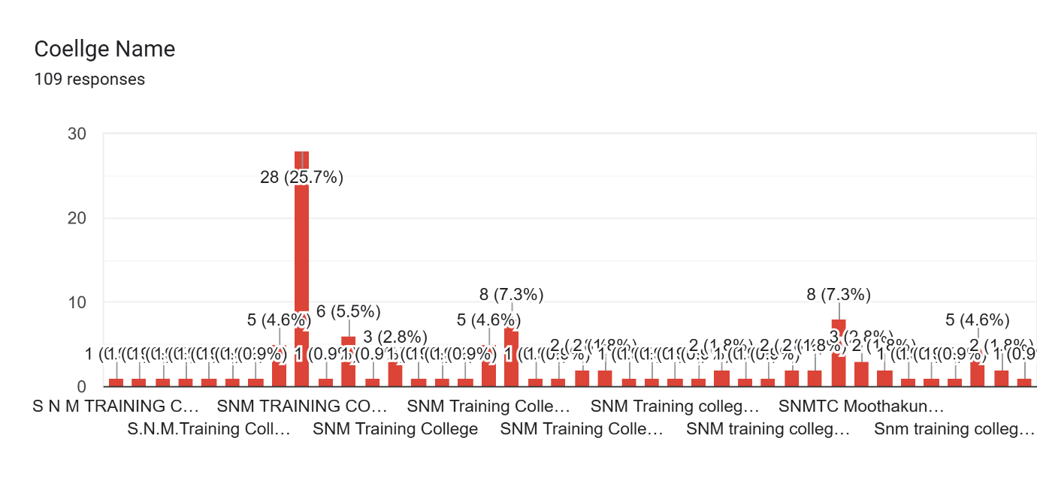

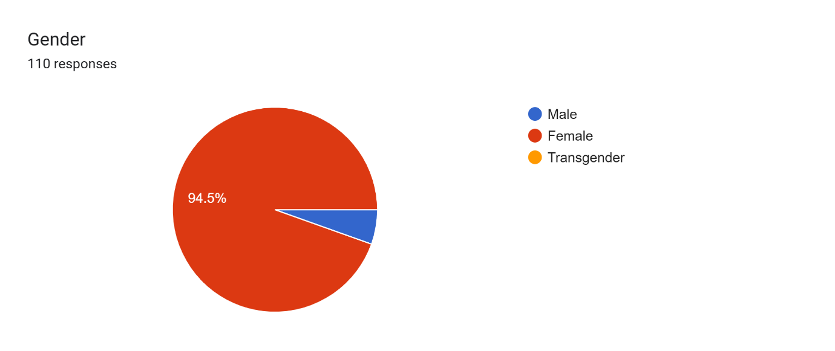

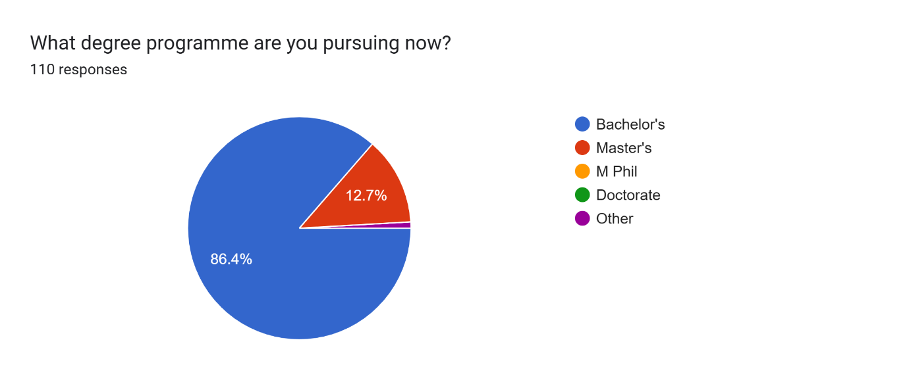

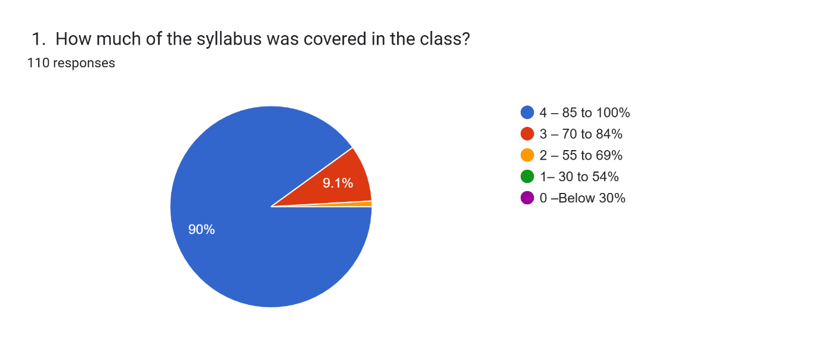

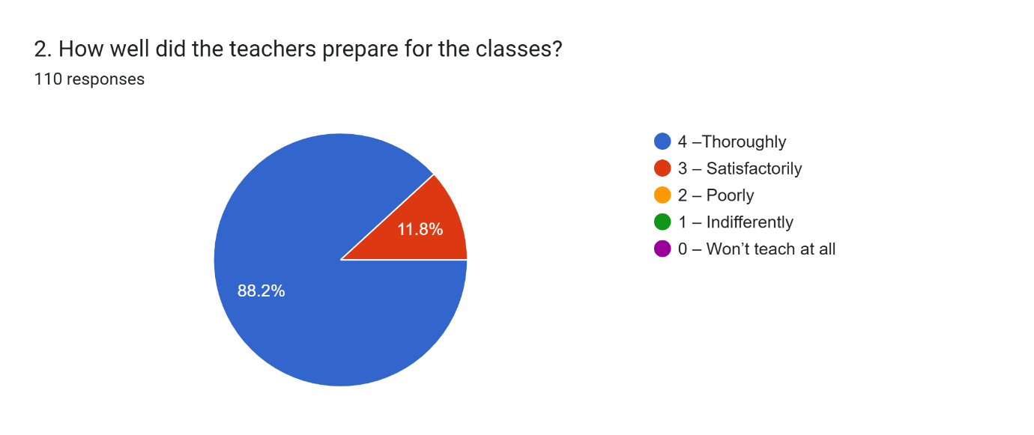

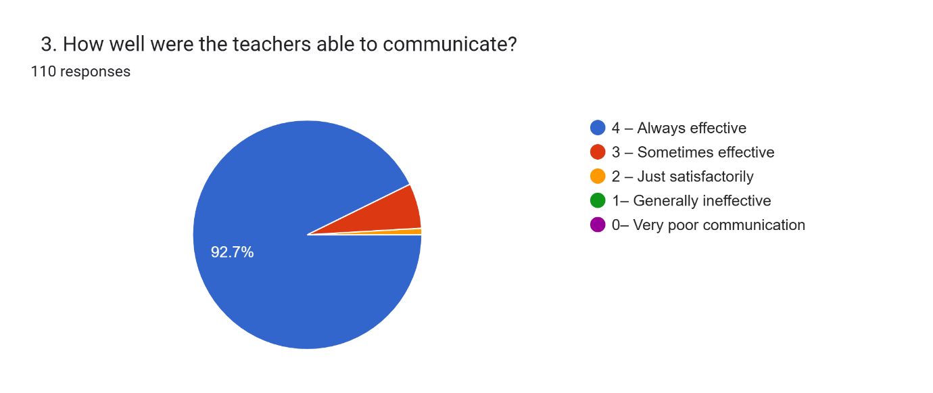

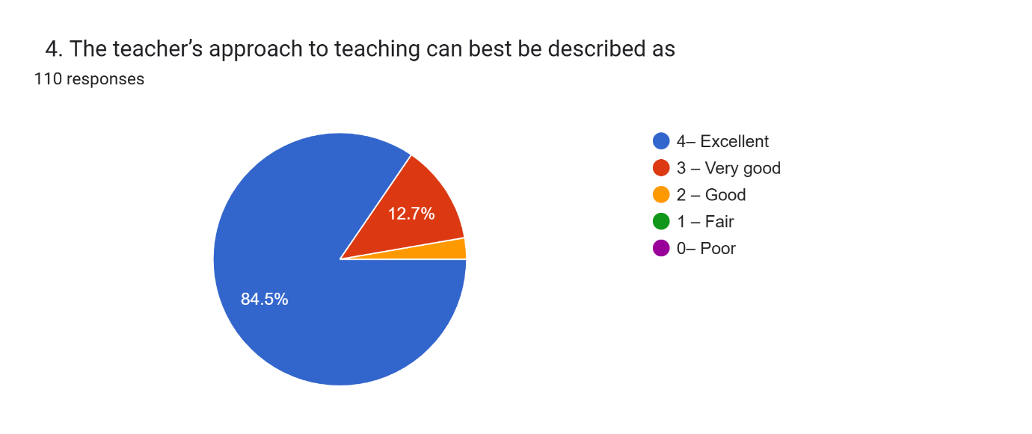

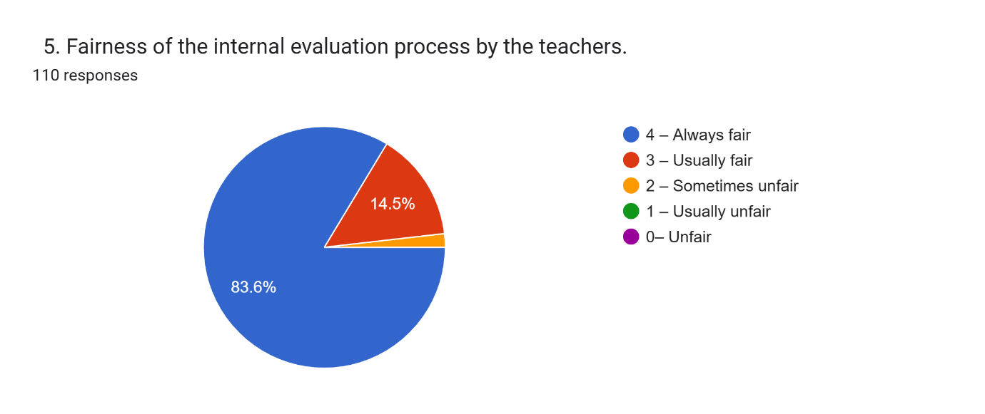

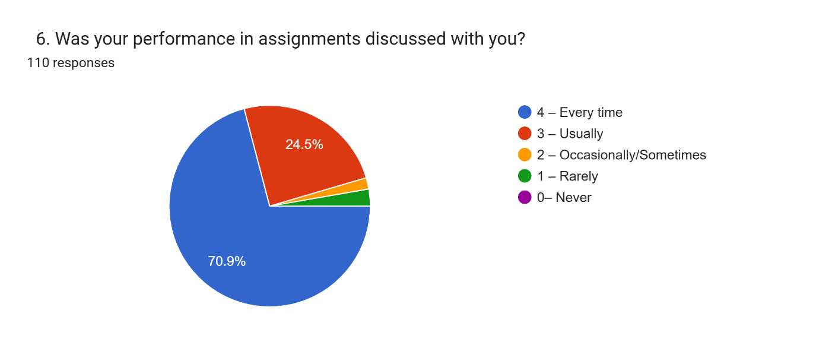

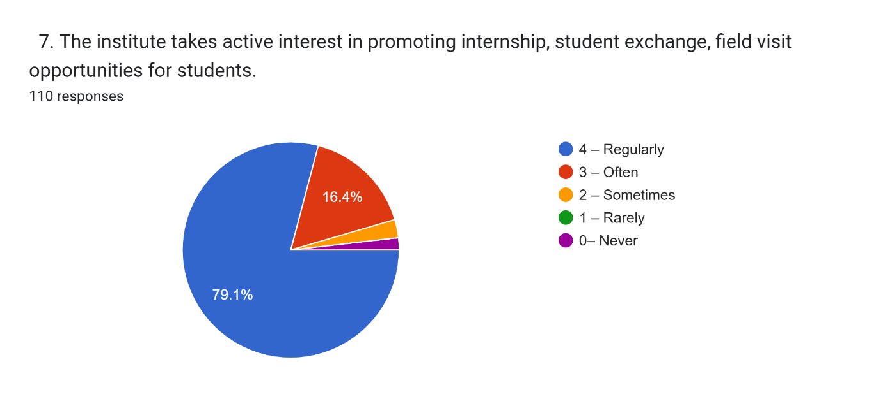

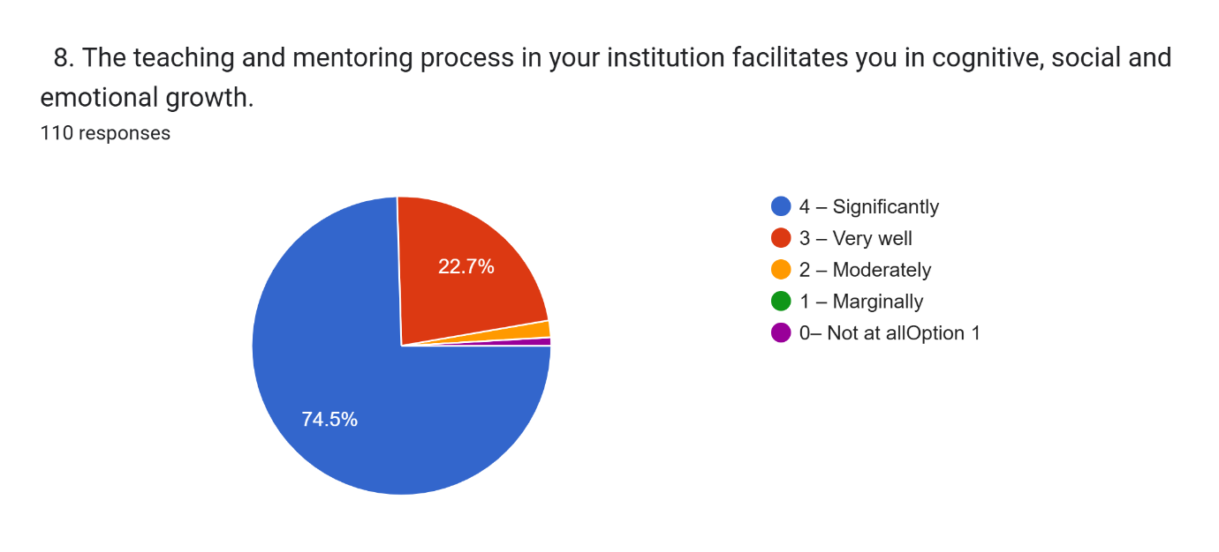

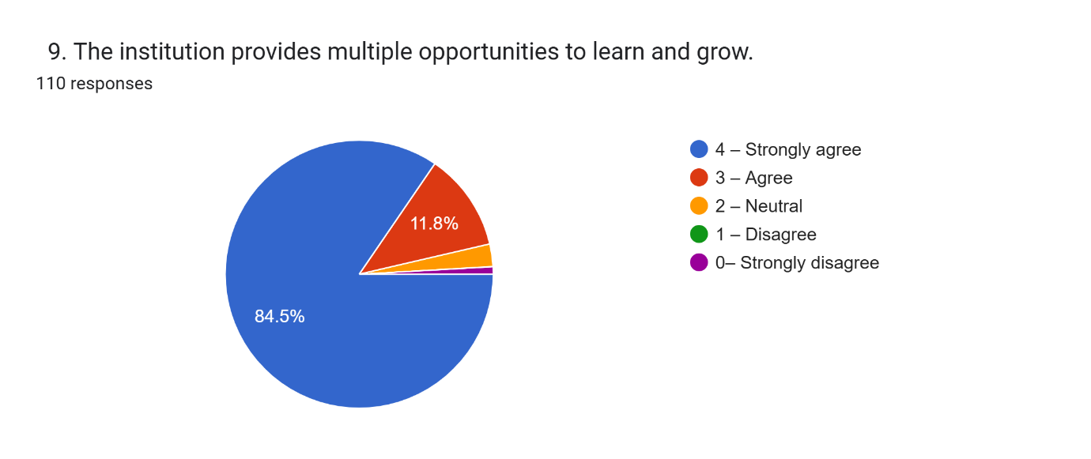

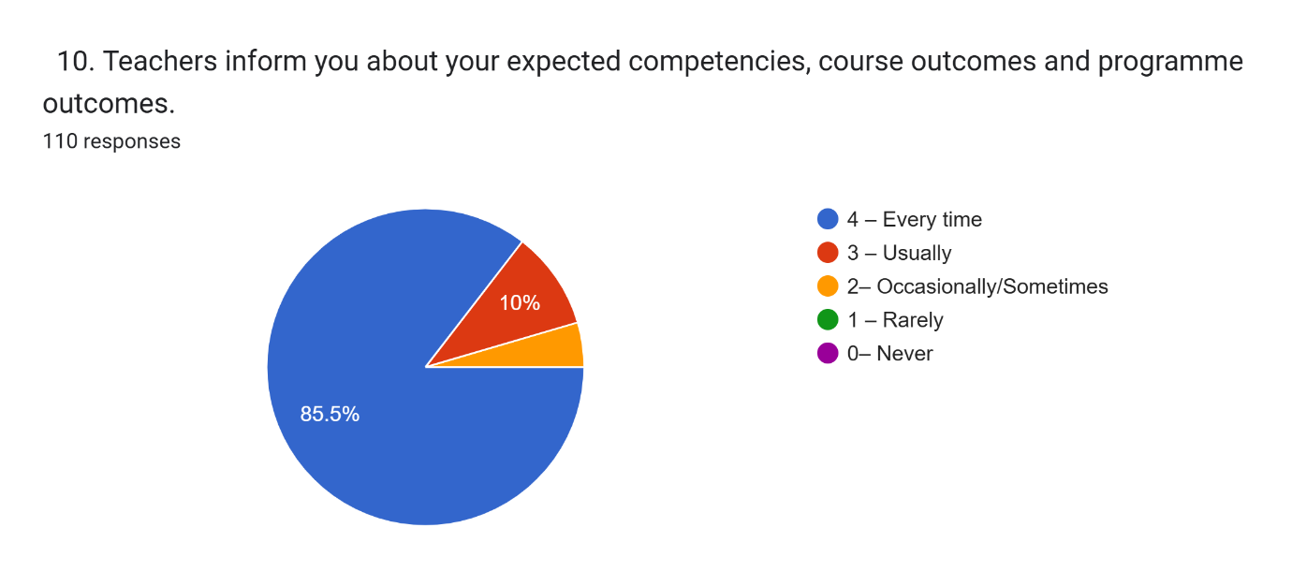

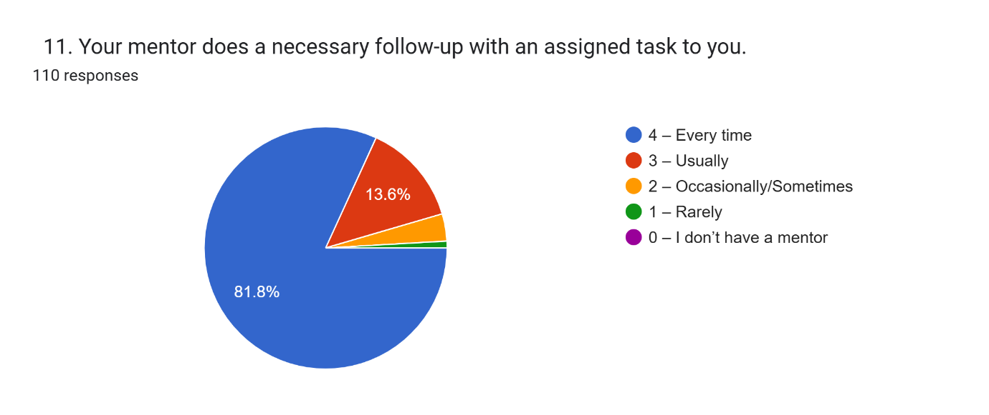

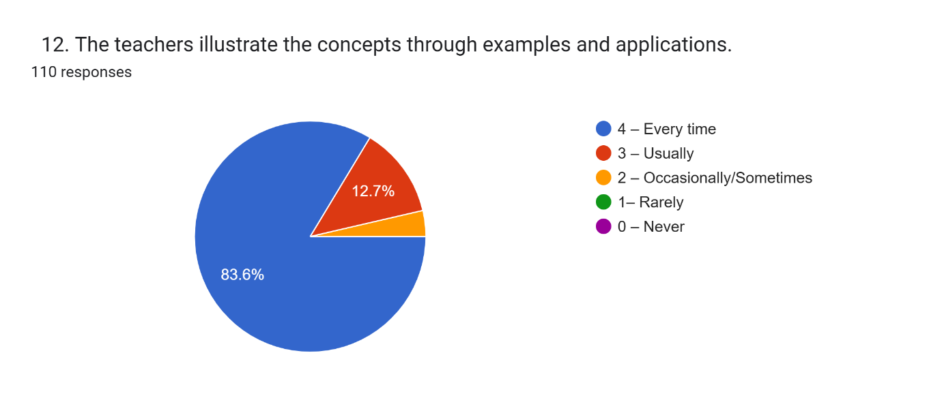

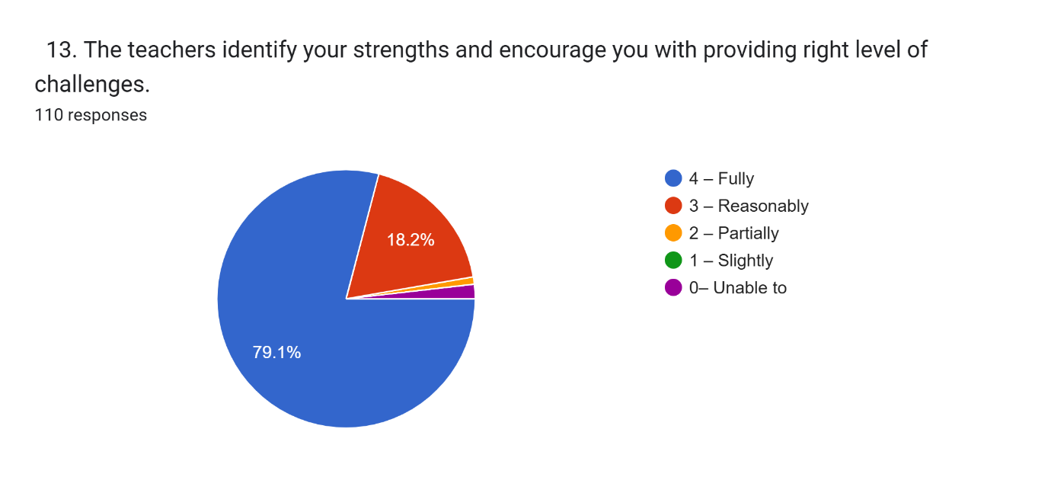

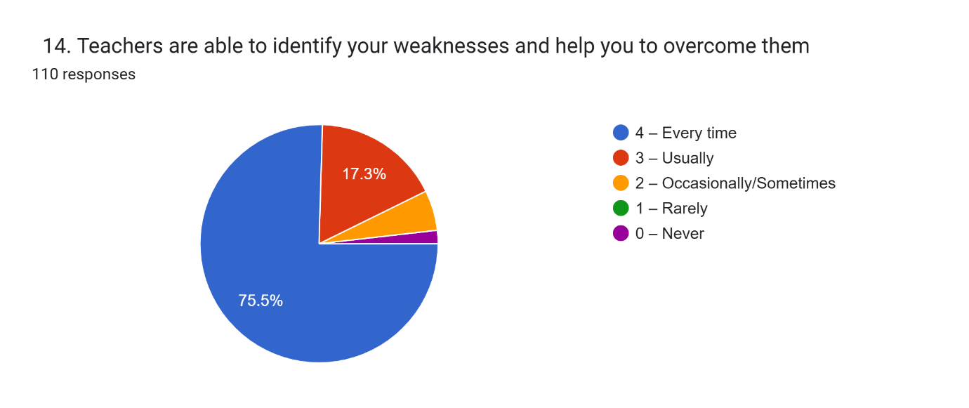

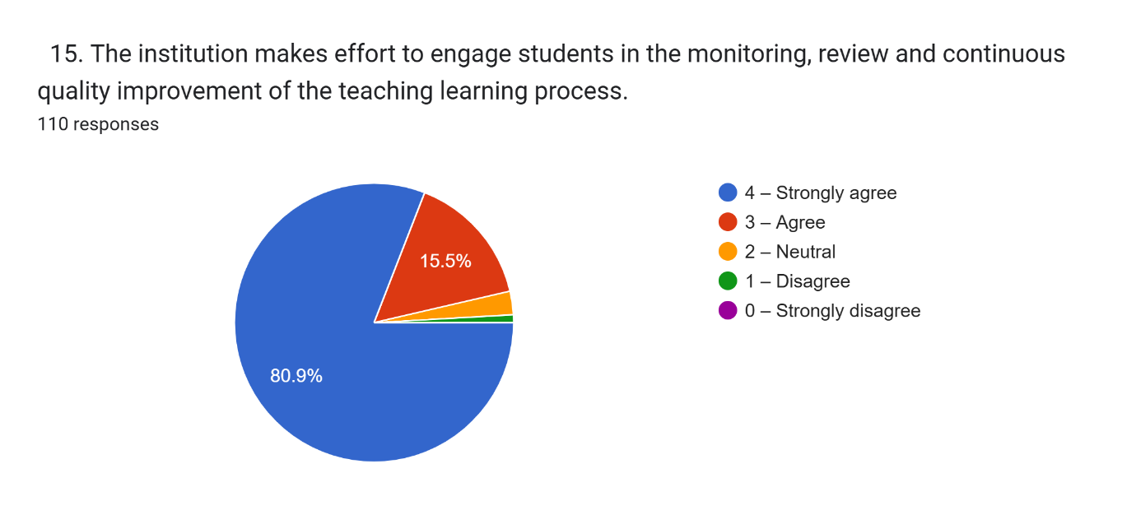

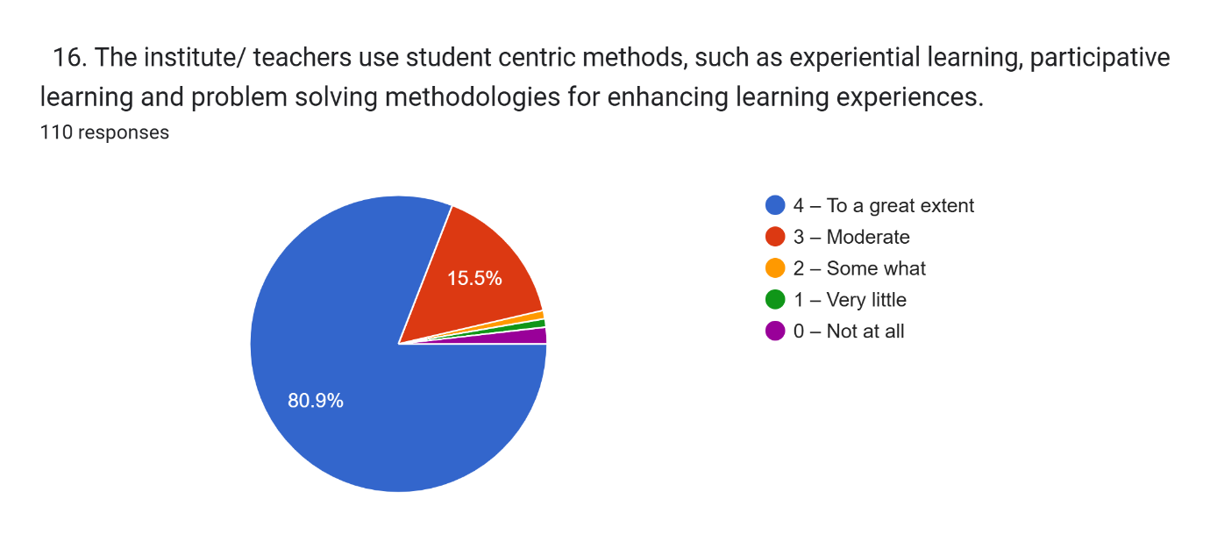

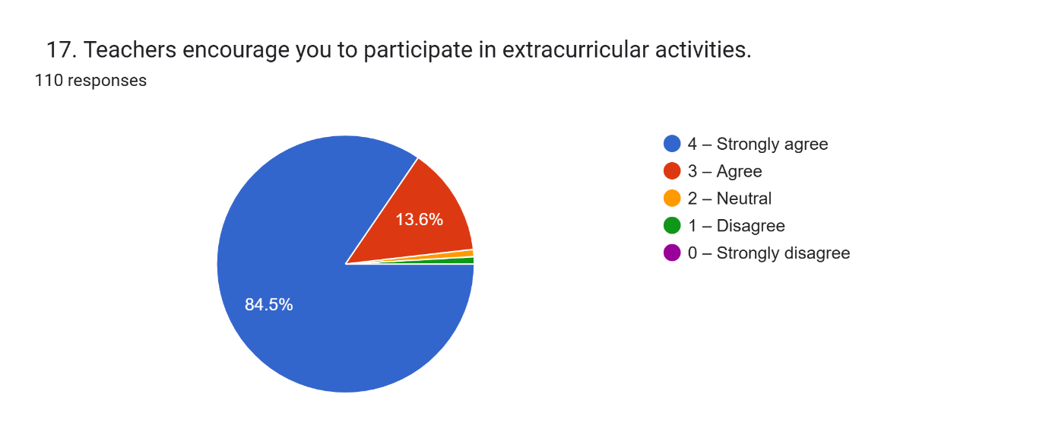

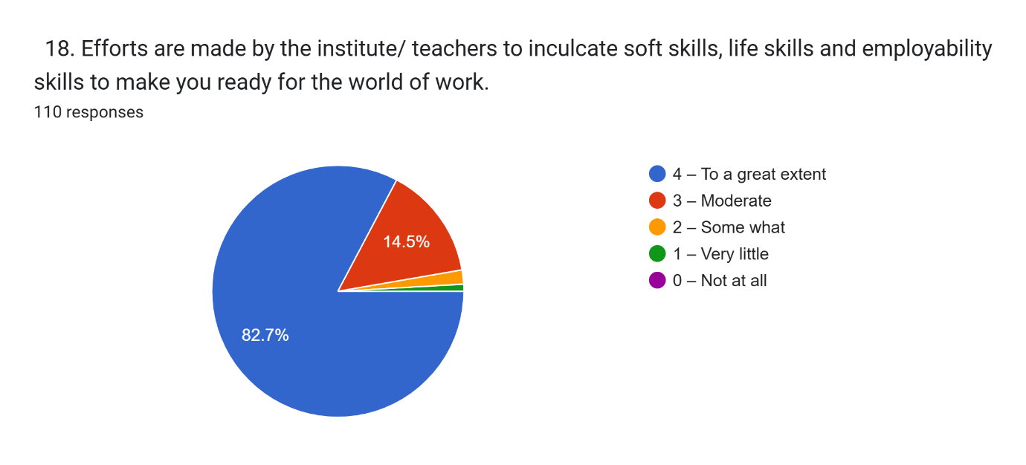

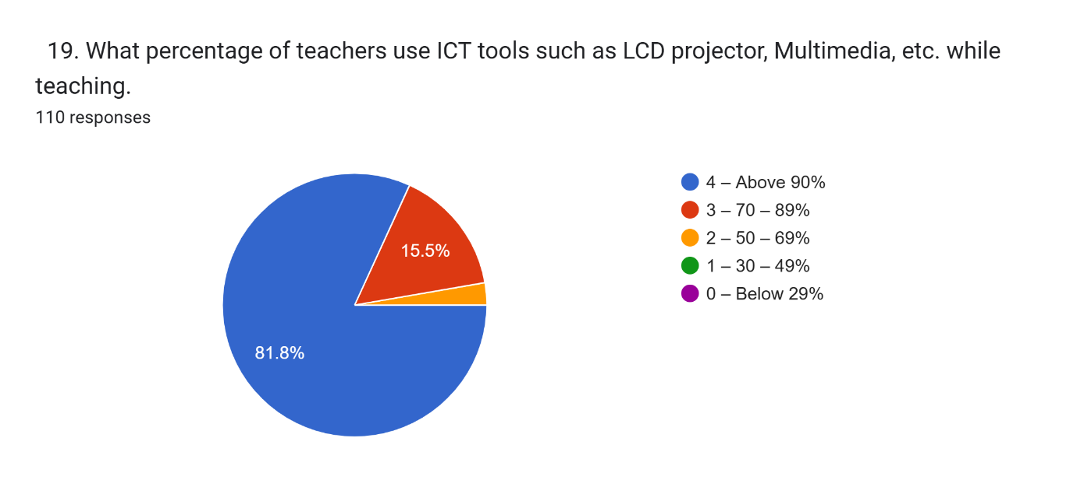

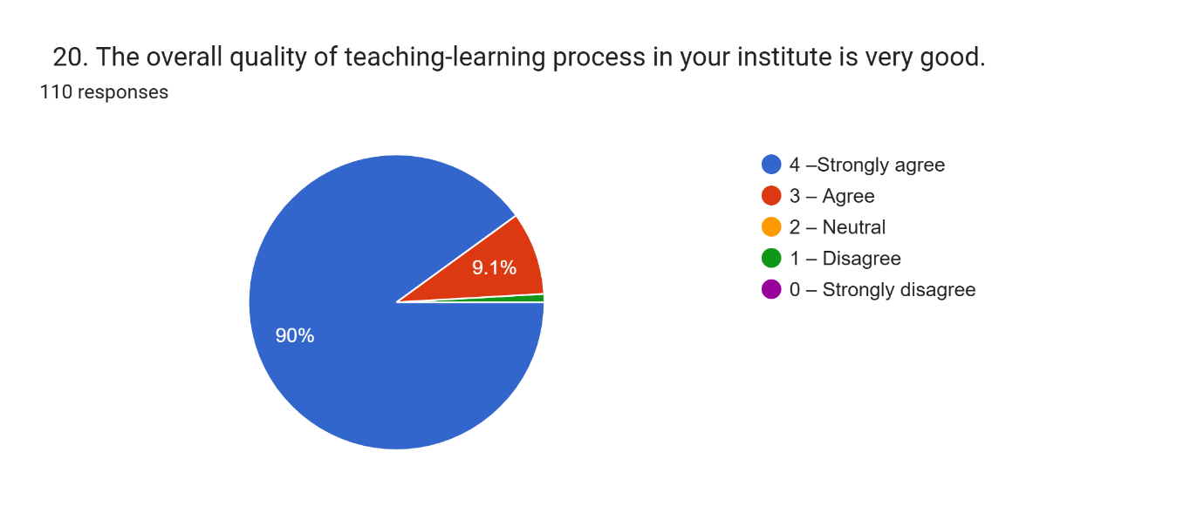

1. Give three observation / suggestions to improve the overall teaching – learning experience in your institution.
2. 110 responses
3. No suggestions
4. .
5. Nil
6. Good
7. 1
8. NIL
9. No suggestion
10. Nothing
11. Nothing
12. New methods of teaching should be adoptex
13. Overall teaching learning experience is good
14. Improve personal communication with students and their problems
15. Keep going like this
16. Have a Xerox facility,store room,Canteen,Useful workshops
17. * Being much more activity oriented *providing activities outside the college * making a laison with resource person
18. To use more real life experience in teaching learning process
19. Ensure that students are able to use ICT, ensure IT lab facilities
20. Rivision
21. Very good
22. Teacher's cover syllabus well Teacher's provide necessary mentorship
23. Quick feed back session can be included.
24. Keep going as smiling campus
25. No suggestions
26. *It should be better if spoken English class are available * It should be better if proper time is given for completion of each semester's works efficiently
27. * Wifi facilities must be enabled everywhere in college * Individual mentoring * Need technical training for students to enhance their teaching career
28. Almost all the activities in college are satisfactory
29. A period for interaction
30. Nothinh
31. Can include ICT in class Can include more field visits Practical experience
32. Everything is good
33. active computer lab, provide play area for recreation,
34. Need more advanced infrastructure
35. Improve library facilities
36. Need more ict facilities
37. Provide more outdoor activities
38. Teaching method can be more interesting
39. Use of microphones during lecturing
40. Excellent
41. As a training institution it is significant to teach and train students through ict tools. It would be better if training is provided more through these tools
42. Highly satisfied with the current teaching learning experience
43. More Library hours
44. Satisfied with the current teaching-learning process
45. Ensure student's participation in extracurricular activities like arts, sports Strengthen counselling sessions among students
46. To bring LCD Projector learning for stud ents.
47. Ict integrated Need more Offline teaching
48. No suggestion
49. Interactive sessions
50. Teaching was very effective hence learning.
51. Group studies Cooperative learning Learning with learning aids
52. Need wifi facilities Provide more facilities for physical training Provide training for students in the technical field
53. Overall teaching learning experience is excellent
54. Infrastructure needs to enhanced
55. Satisfied with this.
56. No improvements needed
57. Everything is fine
58. Student centred class rooms
59. Everything is excellent.
60. 1) Should provide special attention to each student 2) Should improve mentor-student connection 3) Calculation of internal marks from class tests and model exams should be revealed to students
61. വിവര സാങ്കേതിക വിദ്യകൾ കുറച്ചു കൂടി ഉപയോഗിക്കുക. കുട്ടികൾക്ക് ഗൈസൻസ് നൽകുക. റിവിഷൻ 100 % നടത്തുക
62. no
63. Access wifi to all parts of college. Check Audio Visual learning materials are working well in each classroom.
64. Add some more activities
65. Computer lab facilities,
66. Students centred Give more trips Field trips
67. 1. Should understand the individual differences of each students. 2. Never compare with other students. 3. Need more field trip.
68. Should adopt student centric methods, should understand individual differences in learning,Never compare the students
69. Over all teaching learning experience is good. One suggestion is to use more ICT tool while teaching
70. 1. Continuity of the syllabus (module wise completion would be effective rather than mixing-up the topics). 2. Effective communication regarding non curricular activities (including the speaker system and the deadlines of certain programs). 3. Ensuring the whole students participation in every programmes ( preferably encourage the shy or non confident students to lead the programmes next time ).
71. I am satisfied with the teaching learning experience of this College.
72. Co cuticular activities
73. Implementing microphones for teachers in general classrooms could significantly enhance audio clarity.
74. 1. Include more field trips. 2. Consider individual differences. 3. Including more unit tests will be more helpful for the final exam.
75. All are very good
76. Language facilities need to be improved.
77. Encourage the participation of students in cultural events Provide opportunities for students to make use of computer lab Guide students to utilize the resources in the college properly
78. Ground For Physical Education (court for badminton) , Language Labs and more ICT Supports like Smart Boards can be added for a geart Teaching-Learning Experience
79. Great
80. Getting to know the students more personally and giving them motivation will help them progress in their studies. Include feild trips. No more suggestions,iam satisfied with the teaching process in the college
81. 1)Allow more field trip
82. all satisfied
83. 1.Implement active learning strategies 2.Implement wellness programs that support the overall well-being of students. 3.Guest speakers, field trips, and community projects can provide valuable real-world experiences and broaden students' perspectives.
84. All the teachers in this college are very friendly with the students. They provide guidance in all activities.
85. Teaching learning in our institution is very effective
86. Increase duration of class time
87. Use more audio visual aids while teaching
88. 1.Good atmosphere for teaching learning experience in our college 2.Big Library for reference gives vast knowledge to m.ed aspirants 3.Teachers are the best source of knowledge in our college
89. 1.Individual attention is given which is appreciable 2.Many opportunities are given there to enhance student's skills
90. Overall teaching and learning experience is very satisfying
91. Increase campus selection for students
92. . There could be provision for flipped classrooms
93. no suggestions
94. Nice campus with great teachers. Good library for reference.
95. Fully satisfied and seeking their full support in entire course
96. nothing
97. Iam satisfied in my college and always happy about studies. Thank everyone for the great effort and support,which they have given. Wish all the best for my college